**Lacrosse Helmet Impact Testing Report**

**BACKGROUND**

For the collection of data, 4 CUEs were used in our test. Three of these devices were placed on specific regions of the helmet, mentioned below, and one was placed on the top of the head of the dummy so that the other devices will have some accurate data to be compared to when collected. The serial numbers of the devices that were used in this specific test were **6EQS, 6EPJ, 6EQ5,** and **6EPW.**

**TESTING LOCATIONS**

*\*\*If gathering impacts and testing on another helmet besides Lacrosse, there may be different areas to place the CUE. It should be known that these CUEs were attached and mounted using either electrical tape or industrial Velcro\*\**

The first CUE, **6EQS**, was mounted vertically on the inside back of the helmet with the “CUE” Visible and lights pointing right.

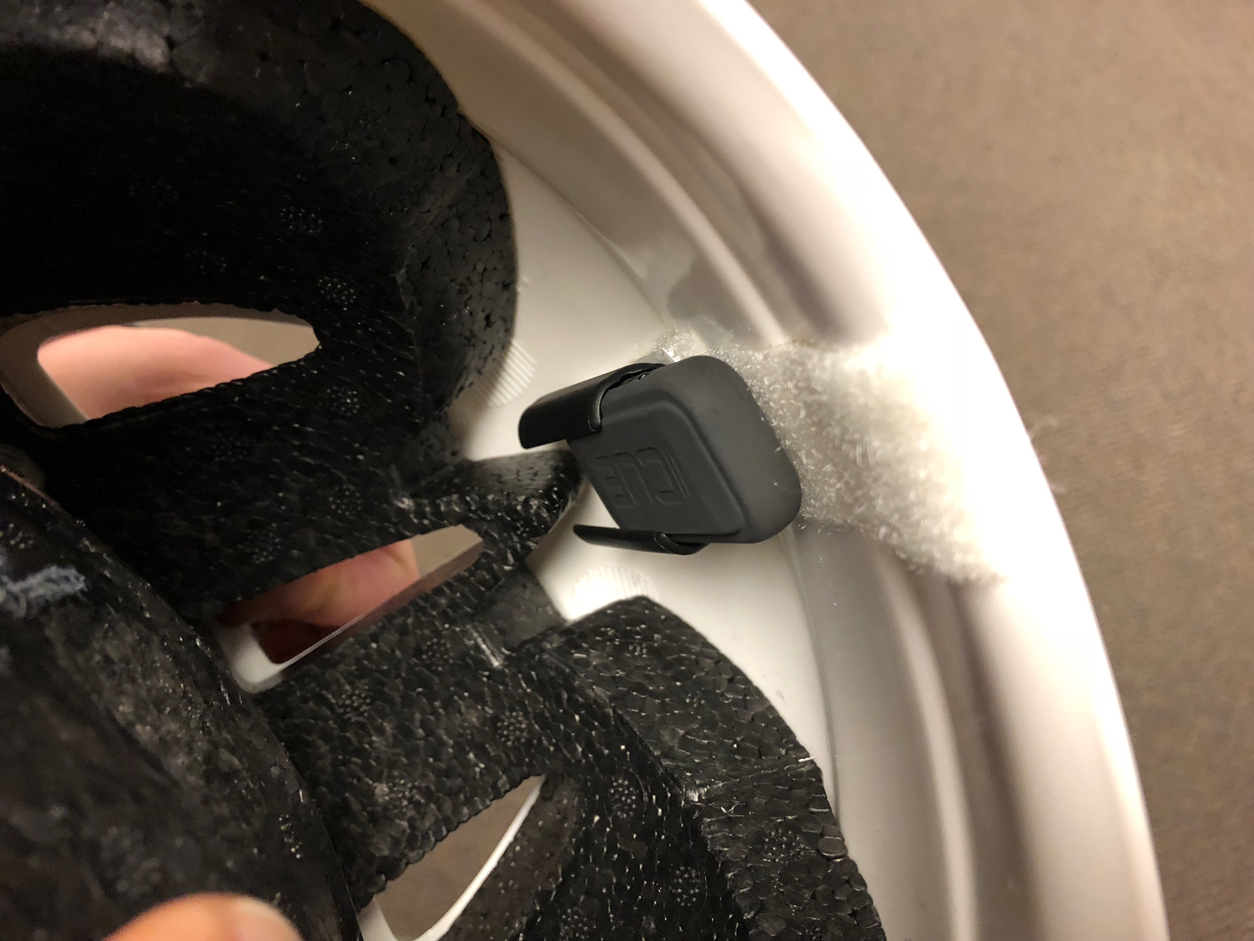

The second one, **6EPJ**, is located on the back of the helmet. The device is horizontal with the lights facing downwards when sliding into the clip.

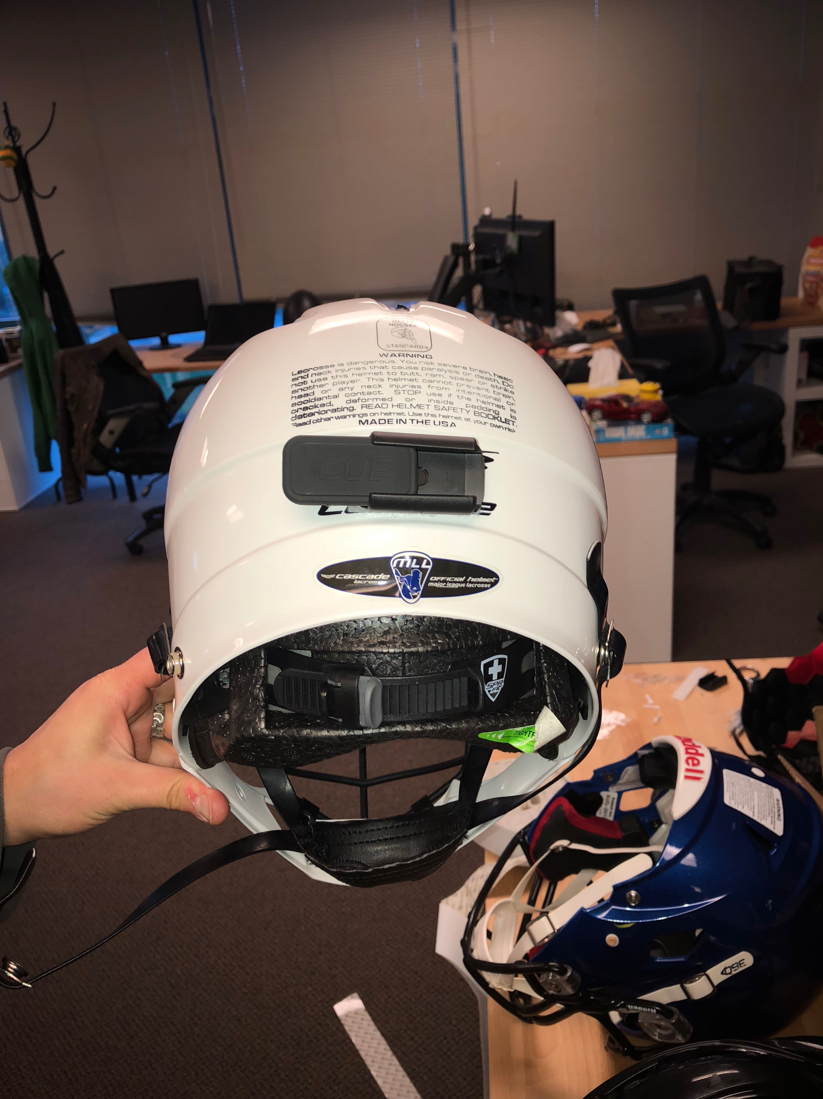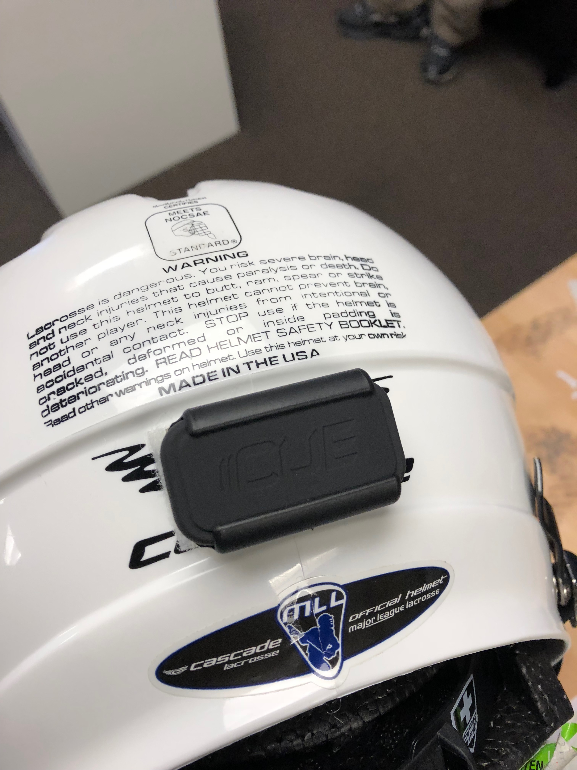

The third, **6EQ5**, being he one located on the top of the helmet. This device has the lights facing the right ear of the helmet wearer.

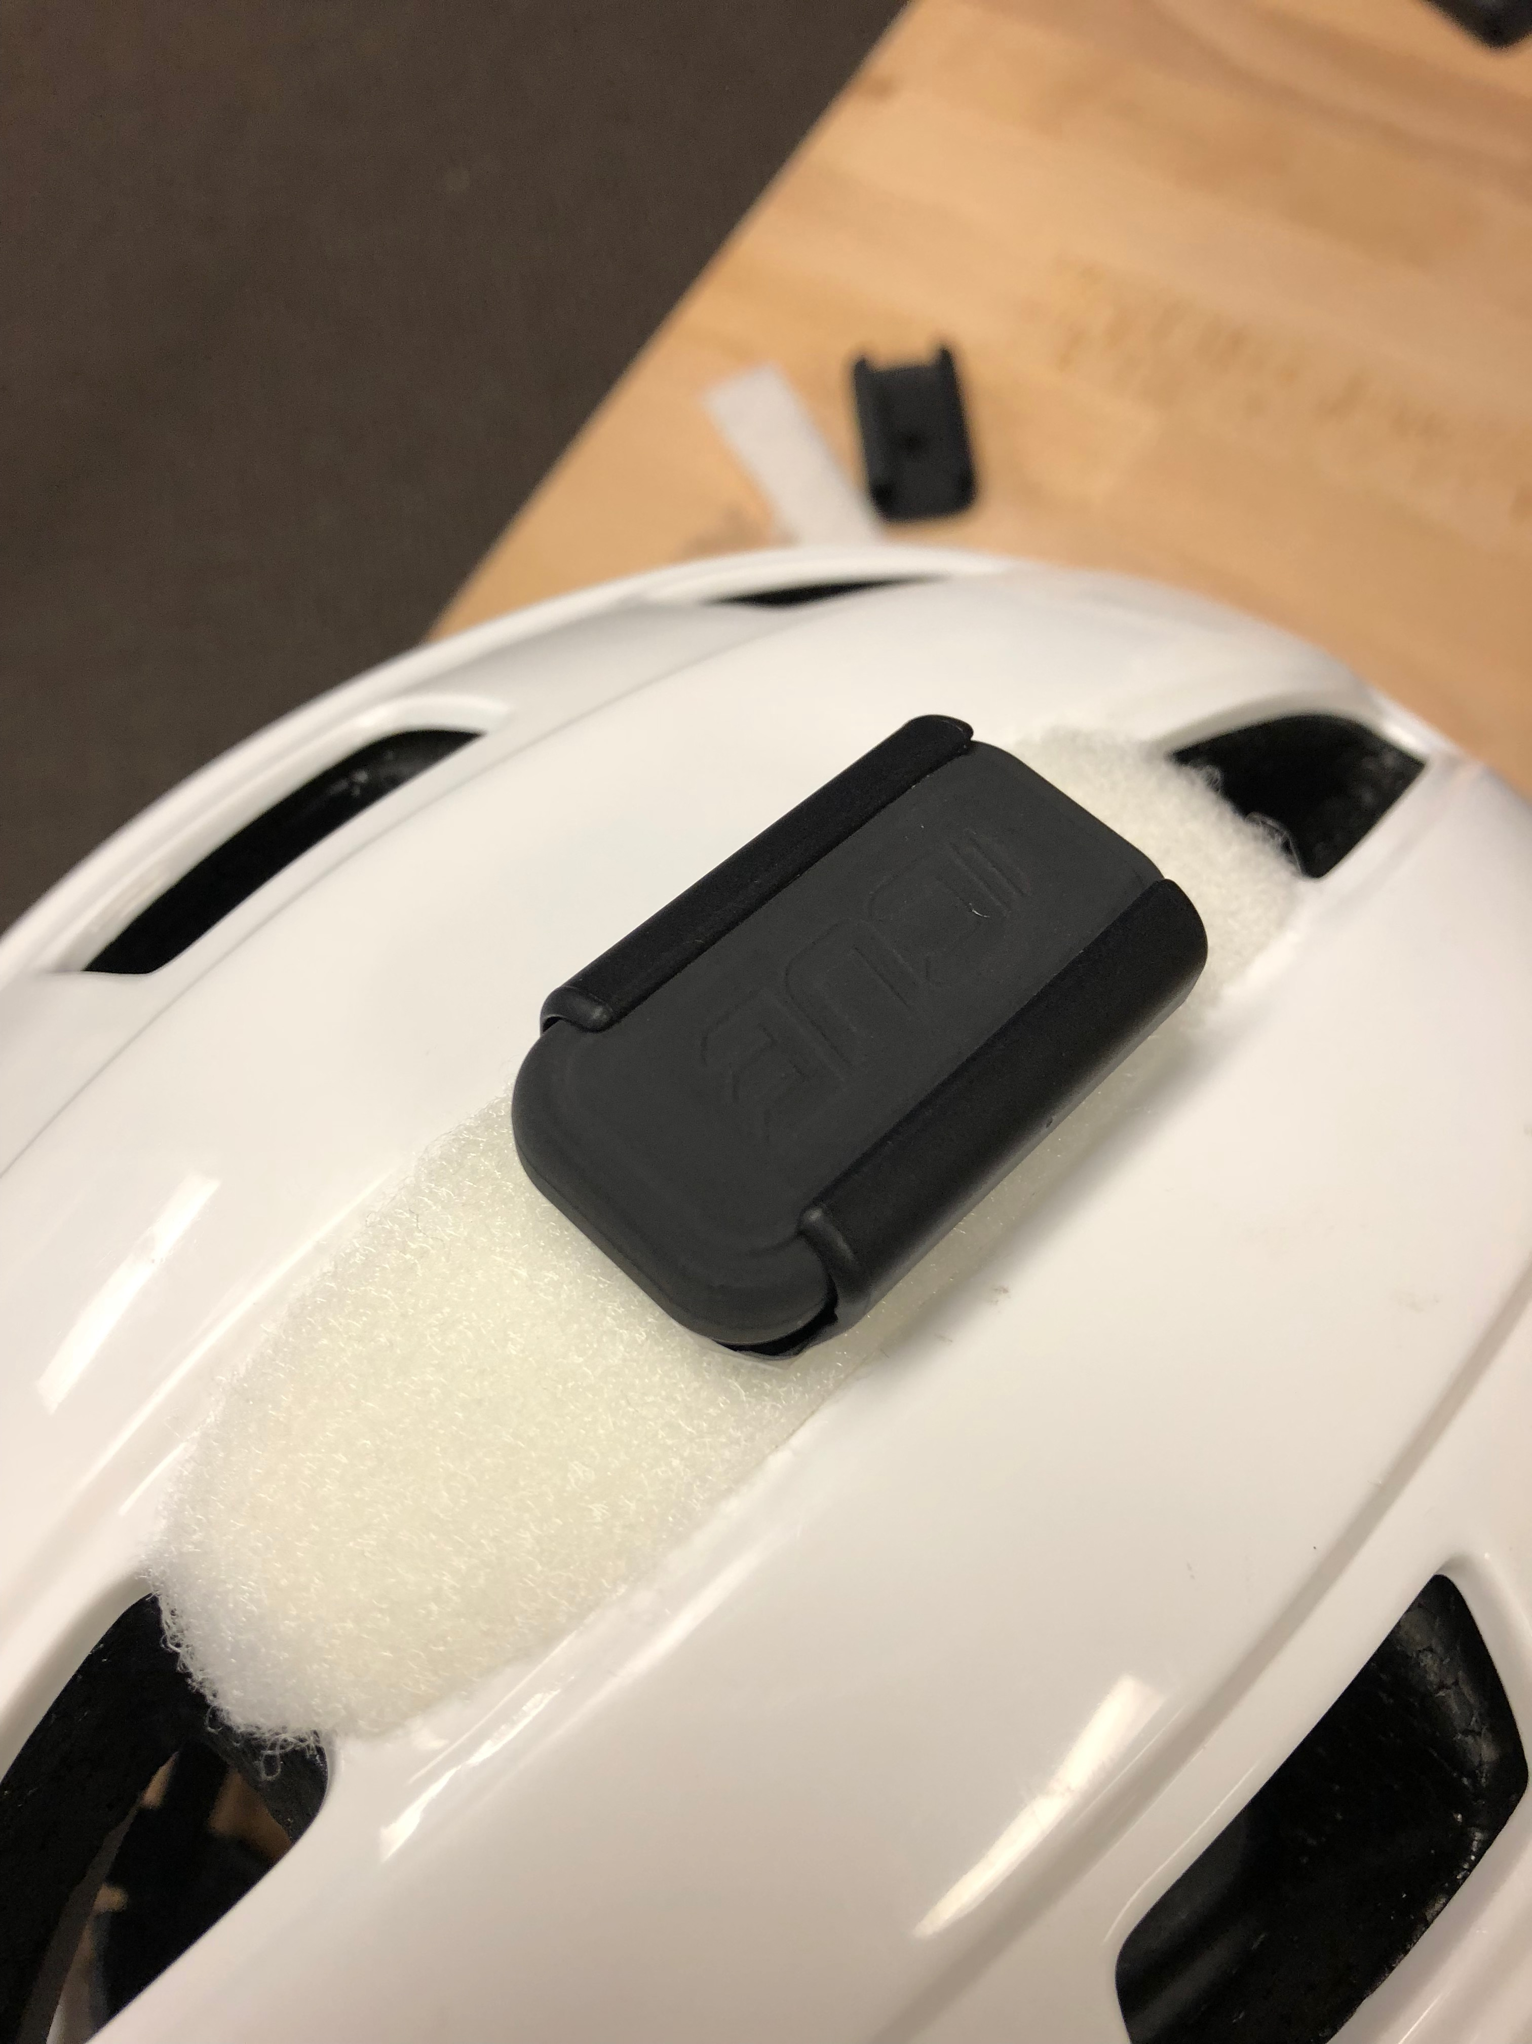

And the last one, **6EPW**, is the calibrated one attached to the top of the head of the test dummy. This device is oriented vertically along the y-axis with the lights pointing to the right.

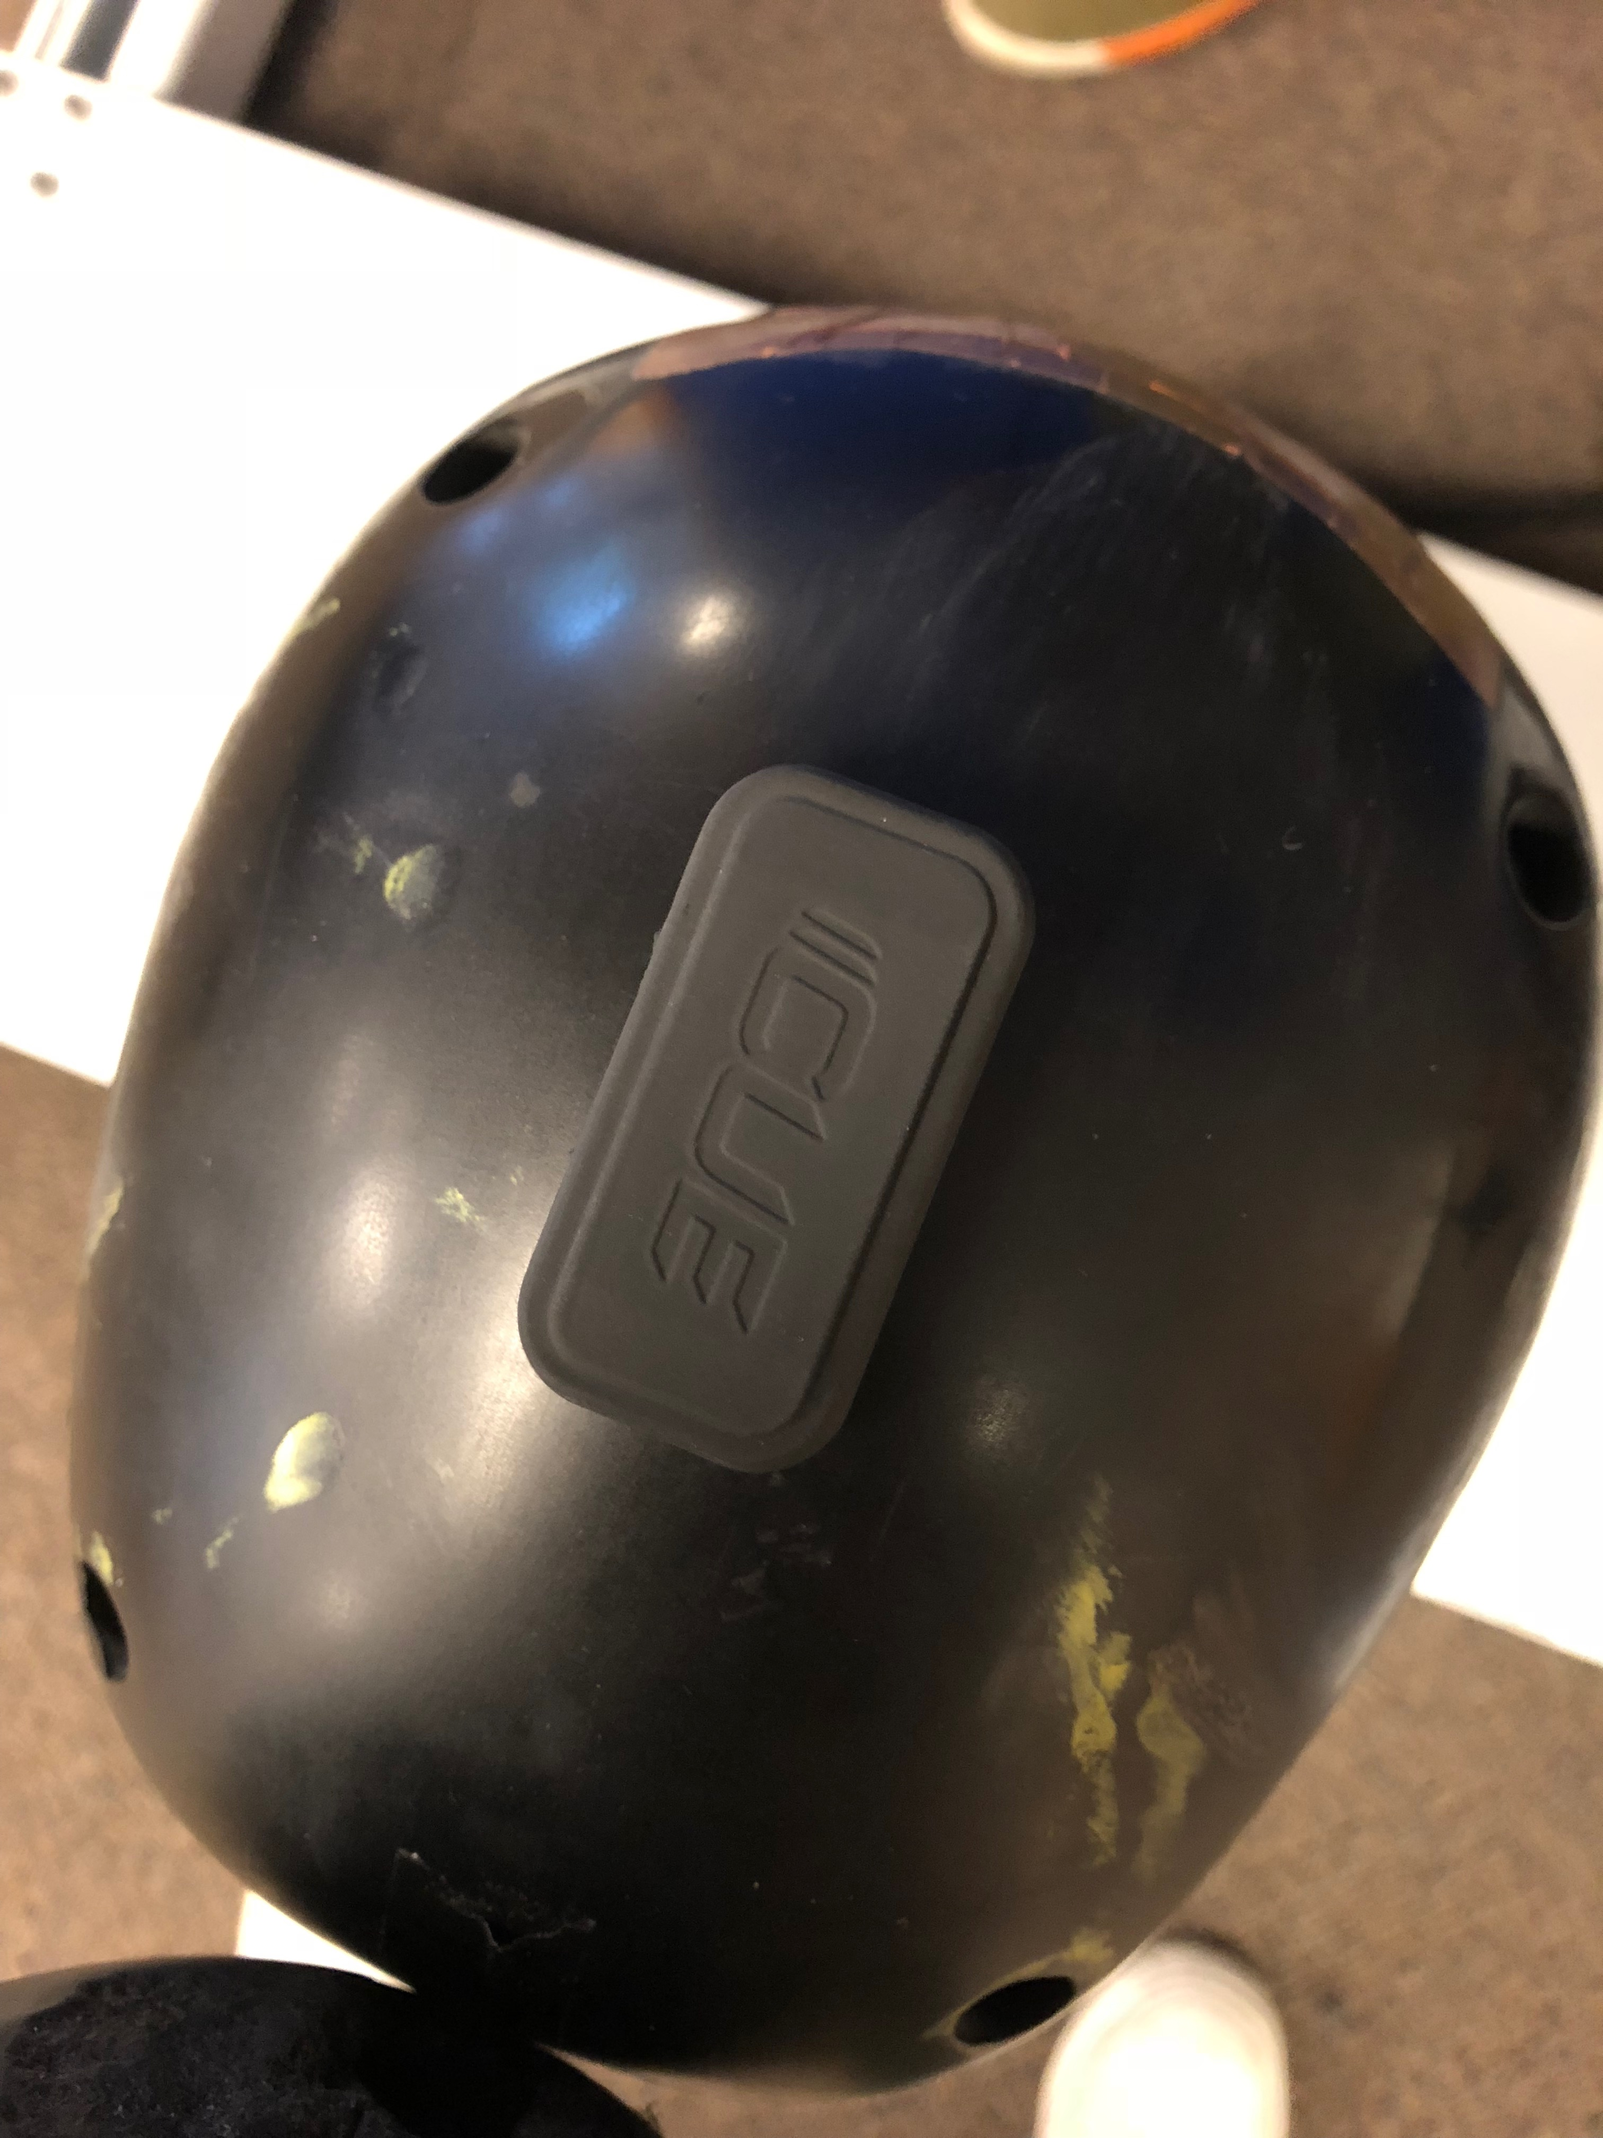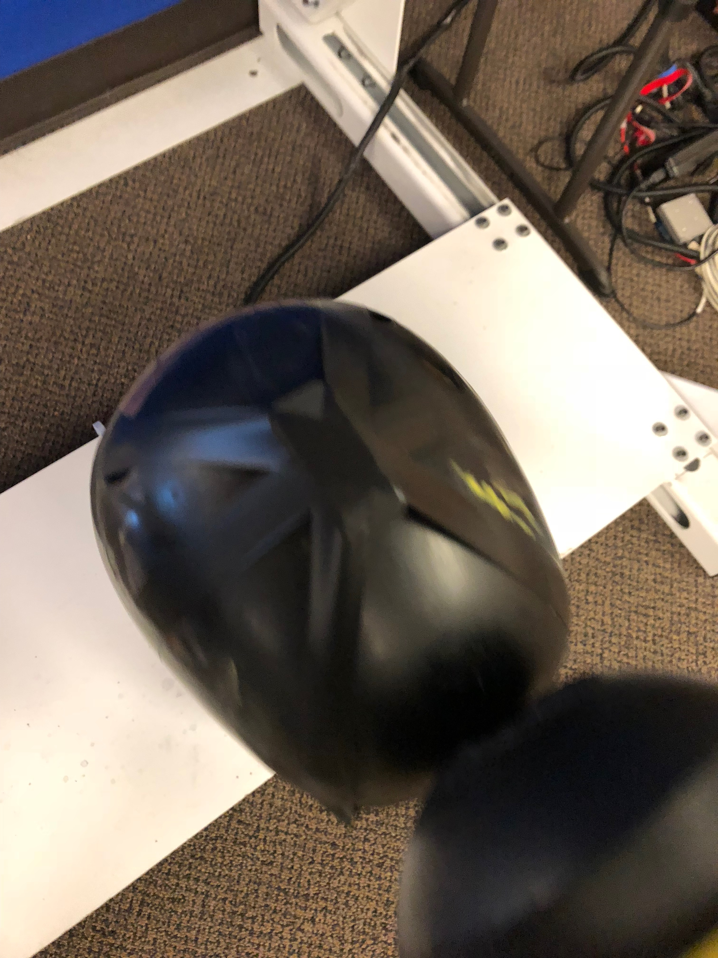

After securing the devices in place on the helmet and on the test dummy. There were several areas we tested to gather data. On a typical test, there were 3 levels of intensity for each area examined: **Moderate, Strong, and Moderate/Low.**

**SETUP FOR TESTING**

CUE devices are needed for testing, the number require could range between 4 and 6 depending on the helmet type and the data that needs to be collected.

Make sure that there is an account with an org, a team and a player ready. Remember to set the team to the specific sport that you are testing for.

After setting up the org, team, and player, if those CUE devices are not in the org already you will have to go through the provisioning process in the AI Sport app as an “Admin” to add them to the org and then add them to the one single player that was created.  
  
If still logged into the account with the org, team, and player from above on it, navigate to the “Device Status” Screen which is located in the “Admin Tab”. Keep this screen up and phone on at all times for testing purposes.

**HOW TO GENERATE AN IMPACT AND RECORD THE DATA**

Once setup, hit the helmet/dummy with another object whether it’s a helmet or a hammer and wait a few seconds so that the CUEs have a chance to process the data and push it to the cloud.

You can tell that the impact is done, when you look at the “Device Status” screen and look for the most recent timing under the column “Battery % and Last Sync”. It is recommended that the time of each processed impact be written so that it becomes easier to tell whether all impacts were recorded properly.

*There will be an excel sheet with the rest of the data to see what was recorded and how.*

**OUR TESTING**

**Right Side**  
The first region that tested was from the right side. The impact was generated with a Riddell helmet. The initial moderate hit was generated a little above the ear. After, the strong hit was directly on the ear and the last being a moderate hit below the ear.

**EX:** [**https://vimeo.com/254358849#t=0s**](https://vimeo.com/254358849#t=0s)

**Left Side**

The second area was the left side of the helmet. It was very similar to the Right Side testing. The first was a moderate hit above the left year of the dummy. The next being a strong hit on the year and the last a moderate hit below the ear.

**EX:** [**https://vimeo.com/254358849#t=5s**](https://vimeo.com/254358849#t=0s)

**Back of the Helm, Top Right, Top Left, Facemask Right, & Facemask Left**

For these testing areas, there was not much a of a difference in the location of each hit for their respective positions but the variance in strength was the same: **Moderate, Strong, Low/Moderate**

Back of Helm EX: <https://vimeo.com/254358849#t=12s>

Top Right EX: <https://vimeo.com/254358849#t=18s>

Top Left EX: <https://vimeo.com/254358849#t=25s>

Facemask Right EX: [https://vimeo.com/254358849#t=31s](https://vimeo.com/254358849#t=0s)

Facemask Left EX: [https://vimeo.com/254358849#t=36s](https://vimeo.com/254358849#t=0s)

**EXTRA TESTING\***

More testing was done to collect some extra data in case that more data was necessary. The areas were only hit once and a different item was used to generate the impacts. The regions of the helm that were tested was the chin, back of the helmet to the right, back of the helmet to the left, and downwards right above the facemask.   
  
*\*\*It should also be noted that the impacts create on the back of the helmets and the one above the facemask were created with a rubber mallet as opposed to the usual Riddell helmet.*

Chin EX: <https://vimeo.com/254358849#t=41s>

Back of the Helm Right EX: [https://vimeo.com/254358849#t=45s](https://vimeo.com/254358849#t=0s)

Back of the Helm Left EX: [https://vimeo.com/254358849#t=50s](https://vimeo.com/254358849#t=0s)

Facemask Left EX: [https://vimeo.com/254358849#t=36s](https://vimeo.com/254358849#t=0s)

Facemask Left EX: [https://vimeo.com/254358849#t=36s](https://vimeo.com/254358849#t=0s)

**OTHER HELMET TESTING LOCATIONS**

**Riddell Helmet**

The first CUE, **6EQS**, was mounted vertically on the inside back of the helmet with the “CUE” Visible and lights pointing right.

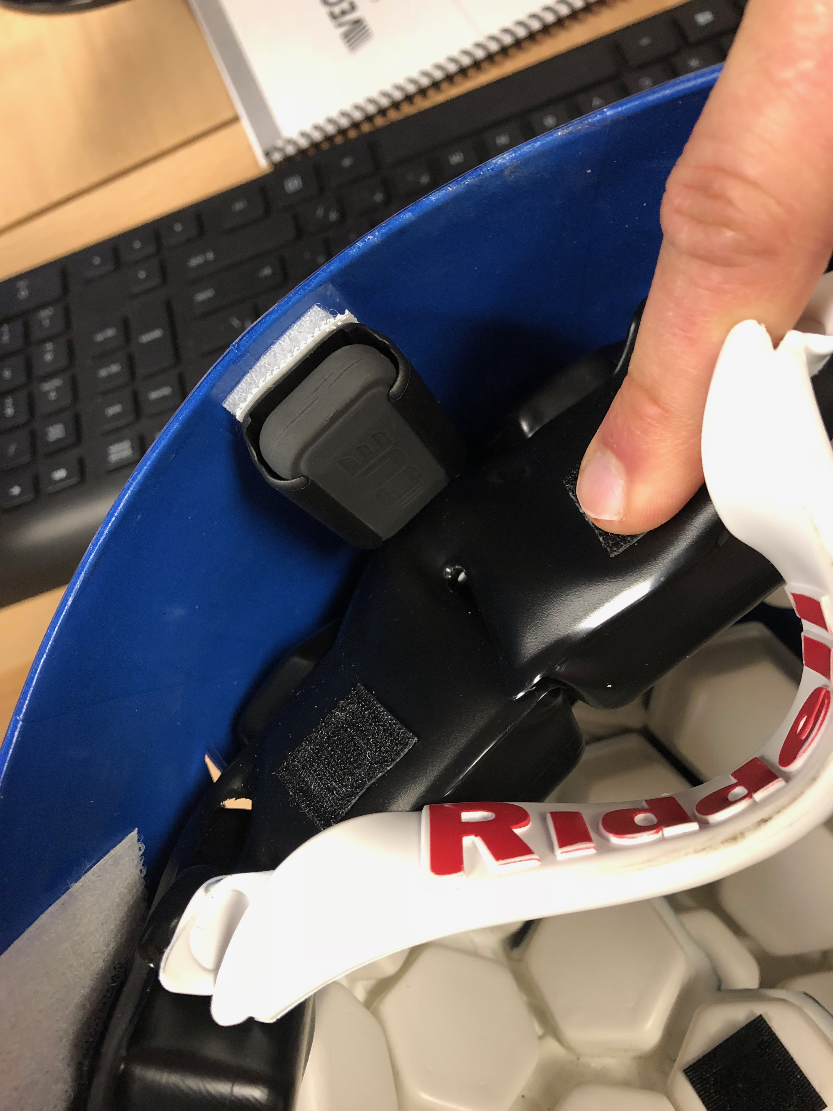

The second one, **6EPJ**, is located in the top right region of the helmet. The device is horizontal with the lights facing the right ear when sliding into the clip.

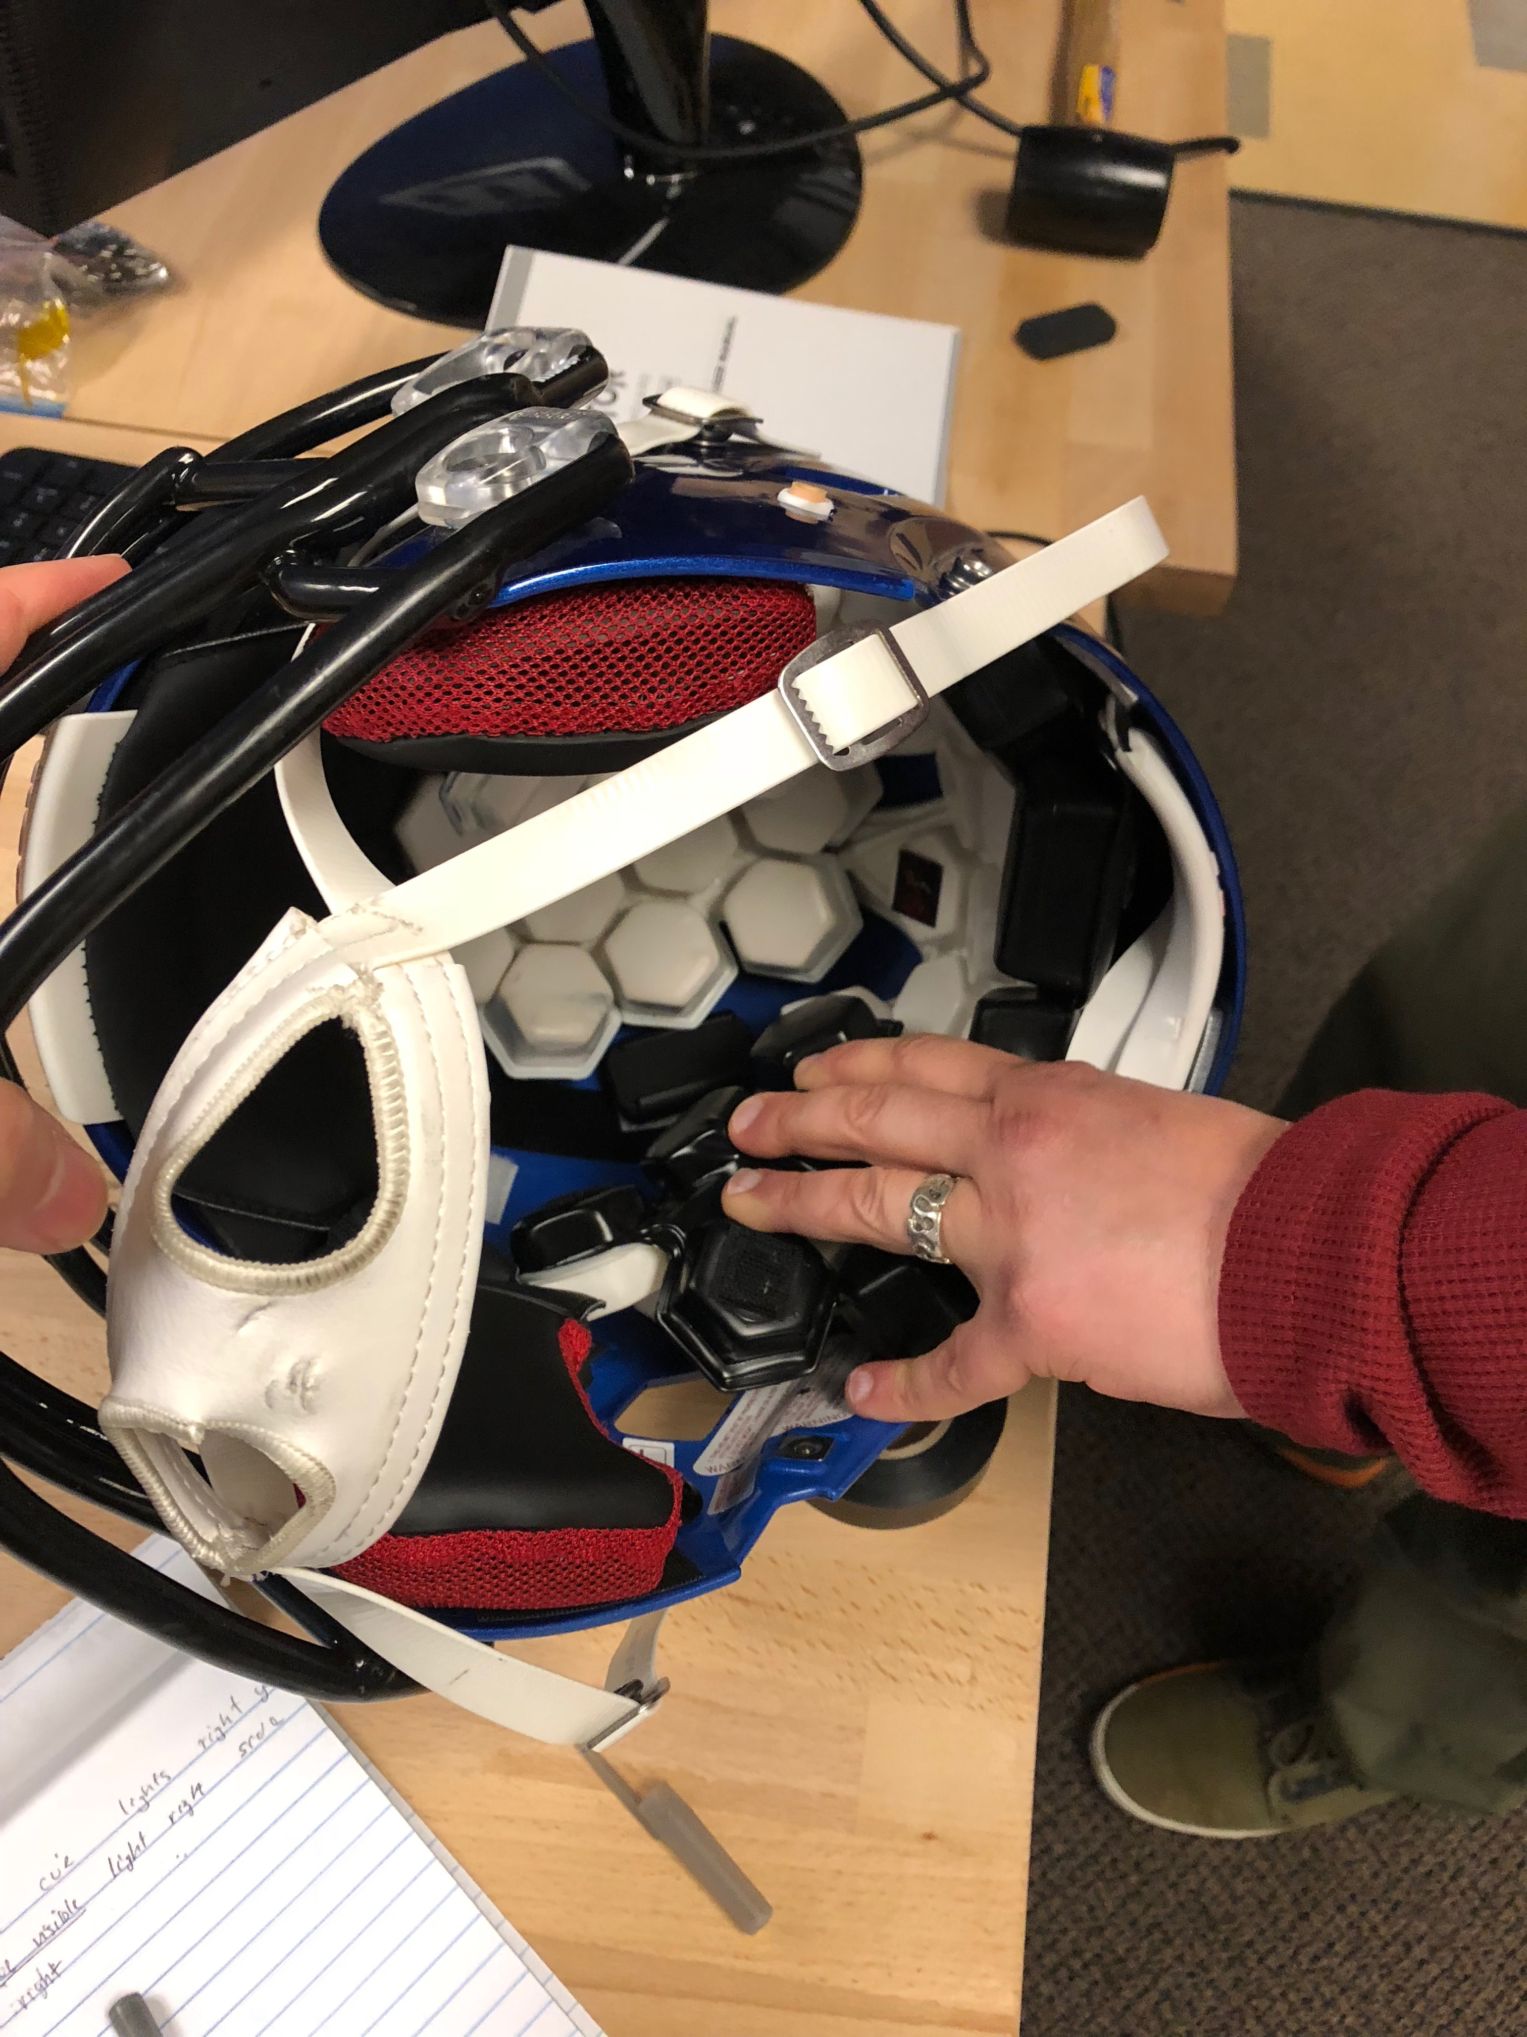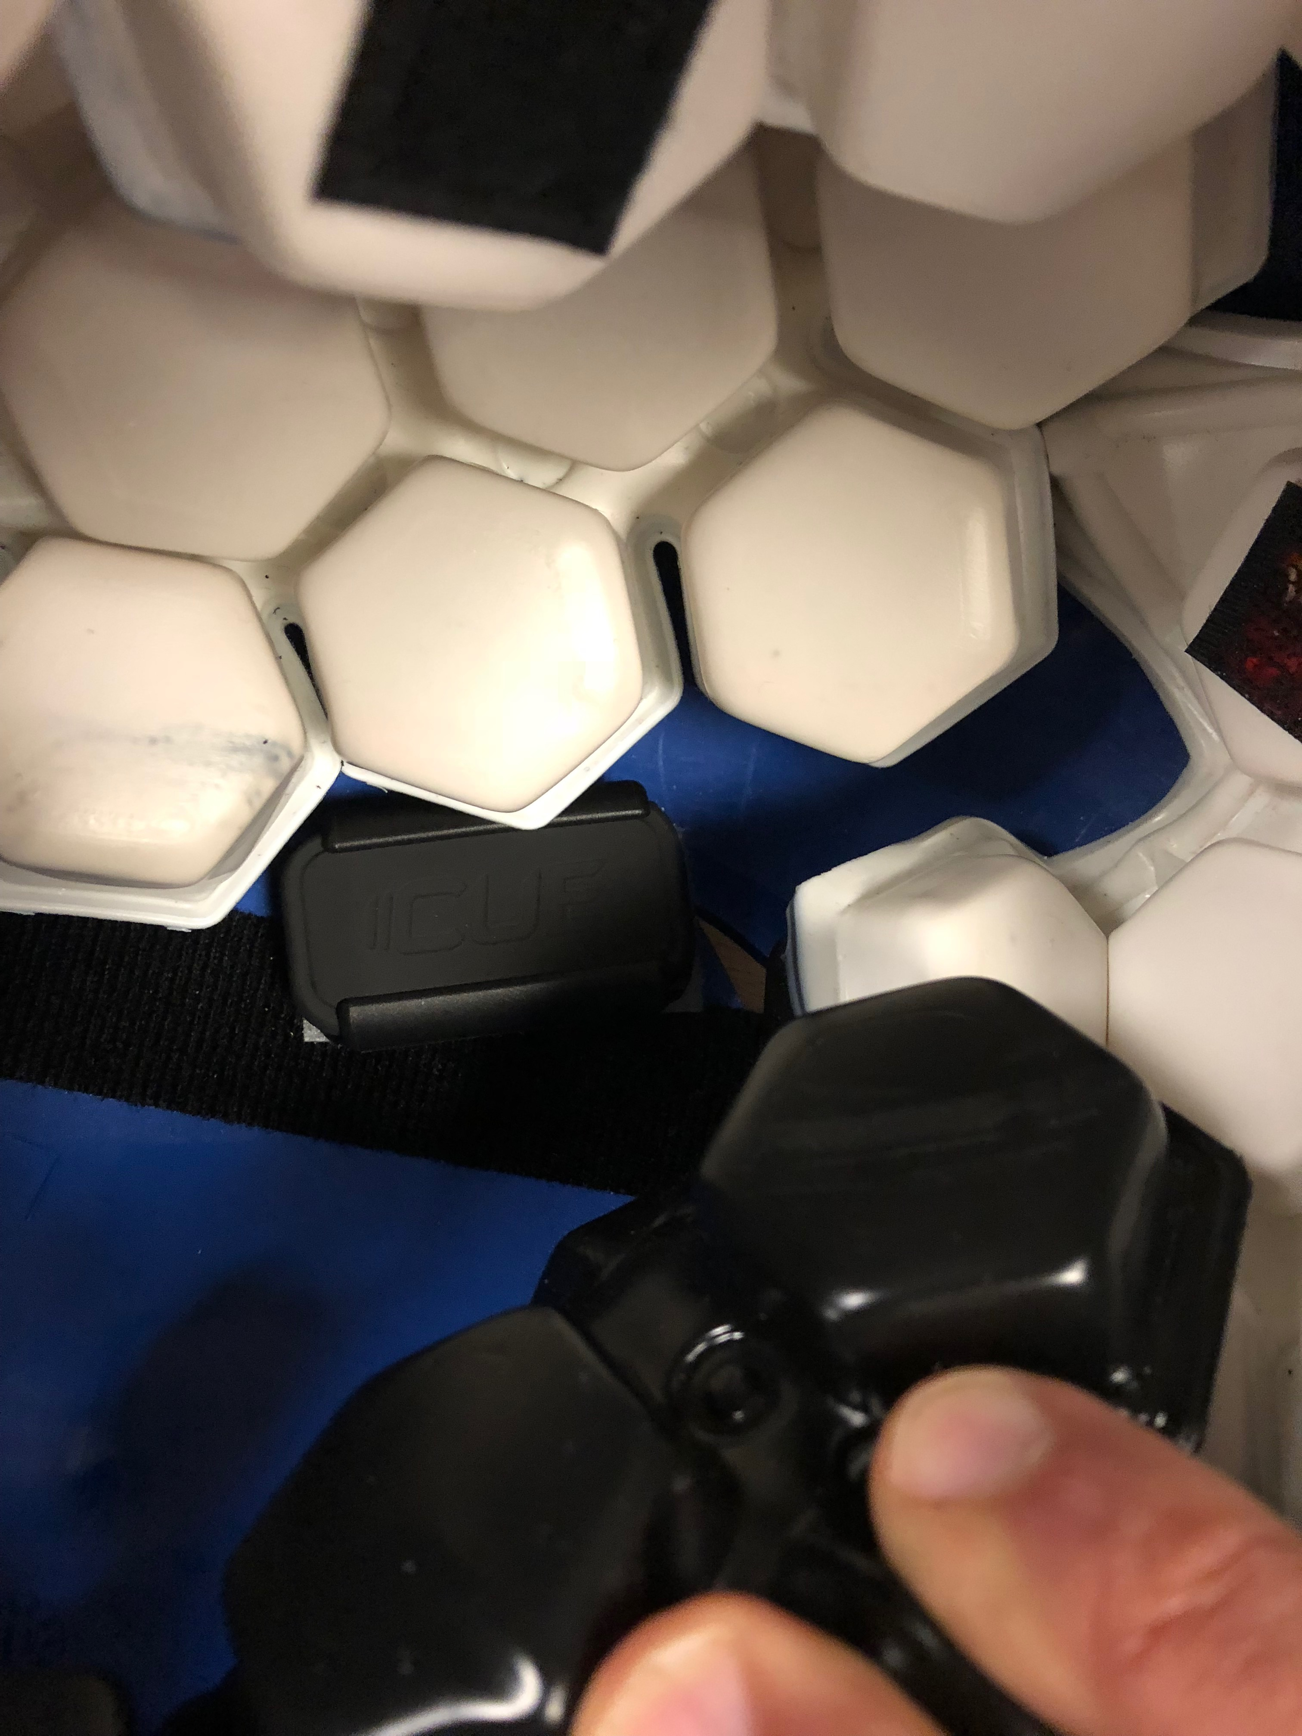

The third, **6EQ5**, is located in the top left region of the helmet. This device has the lights facing the right ear of the helmet wearer.

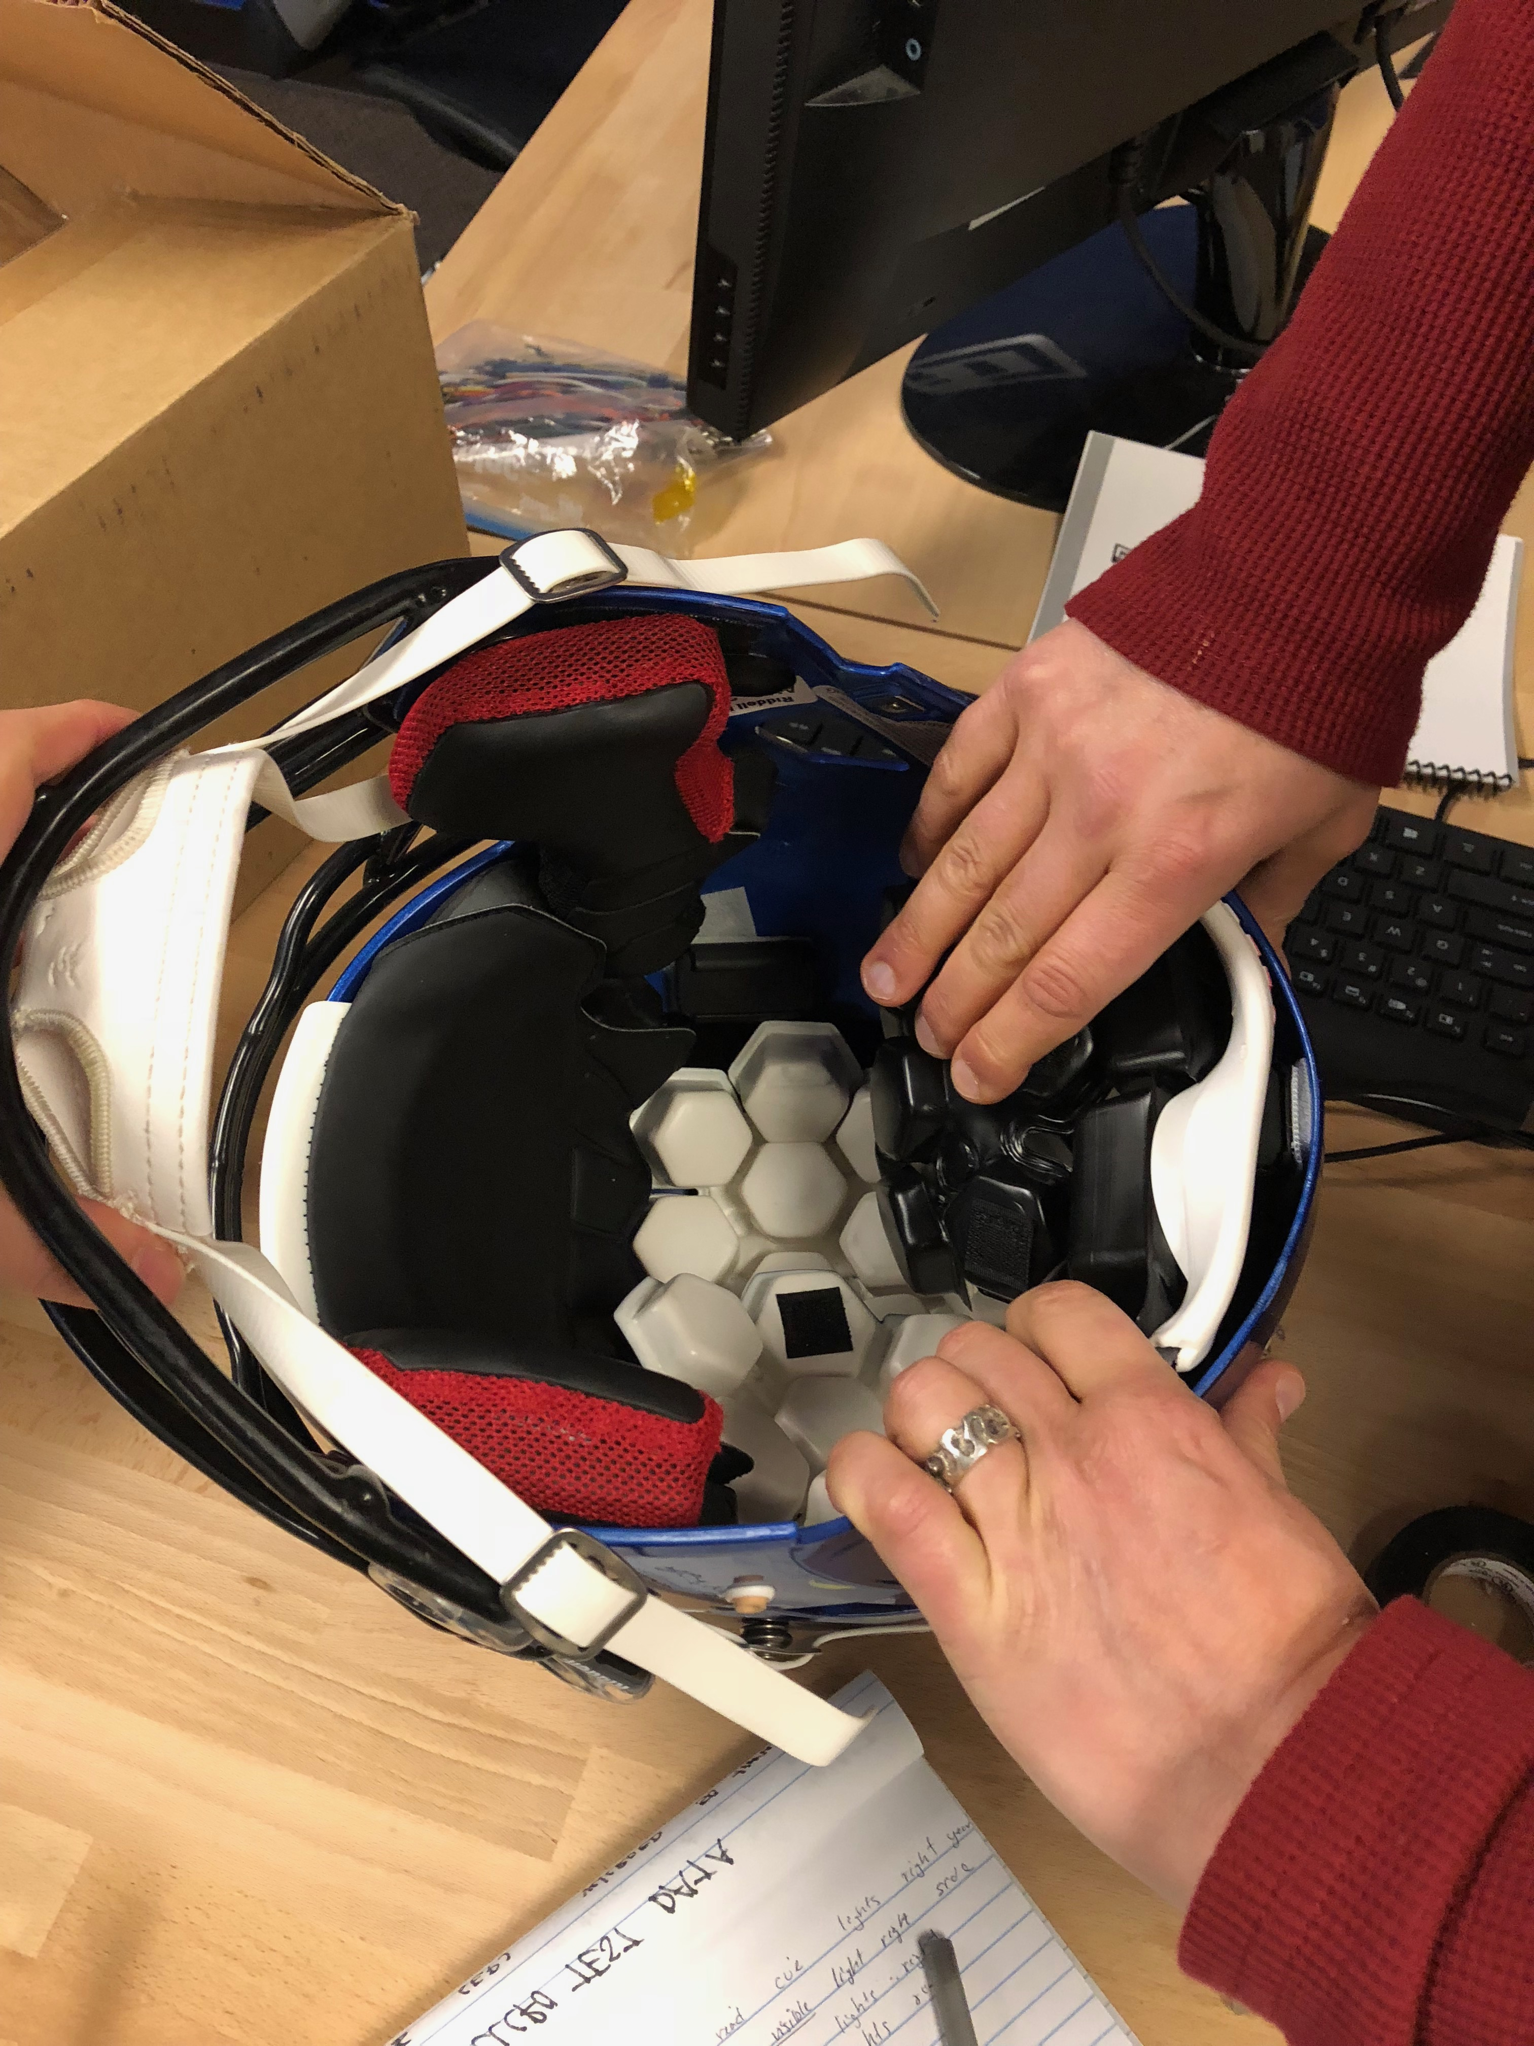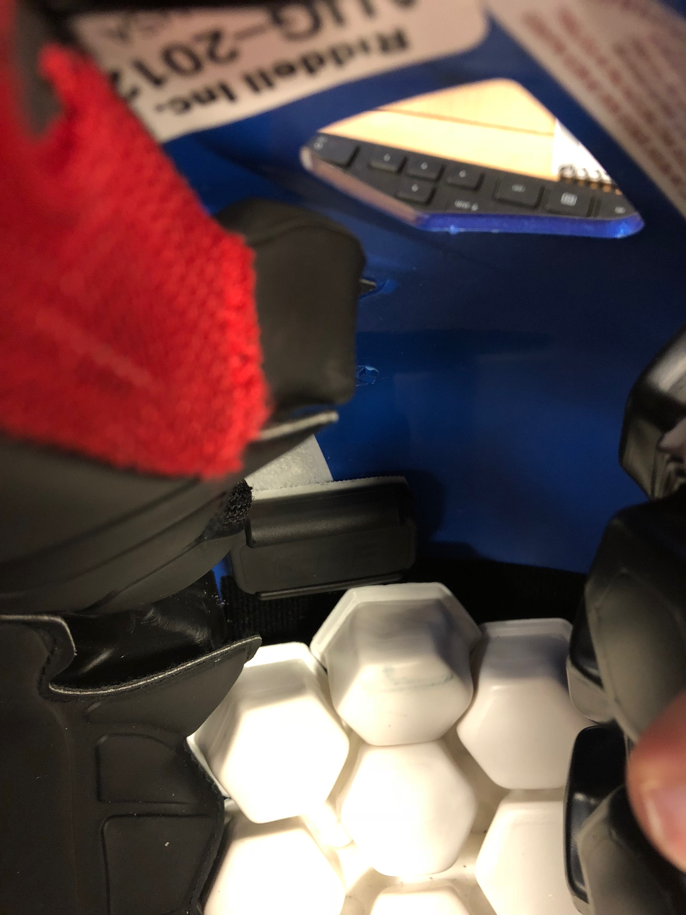

And the last one, **6EPW**, is the calibrated one attached to the top of the head of the test dummy. This device is oriented vertically along the y-axis with the lights pointing to the right.



**Xenith Helmet**

The first CUE, **6EQS**, was mounted vertically on the inside back of the helmet with the “CUE” Visible and lights pointing right.

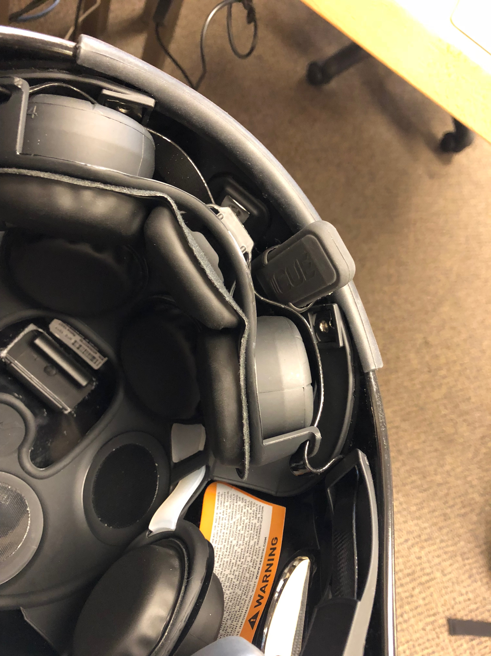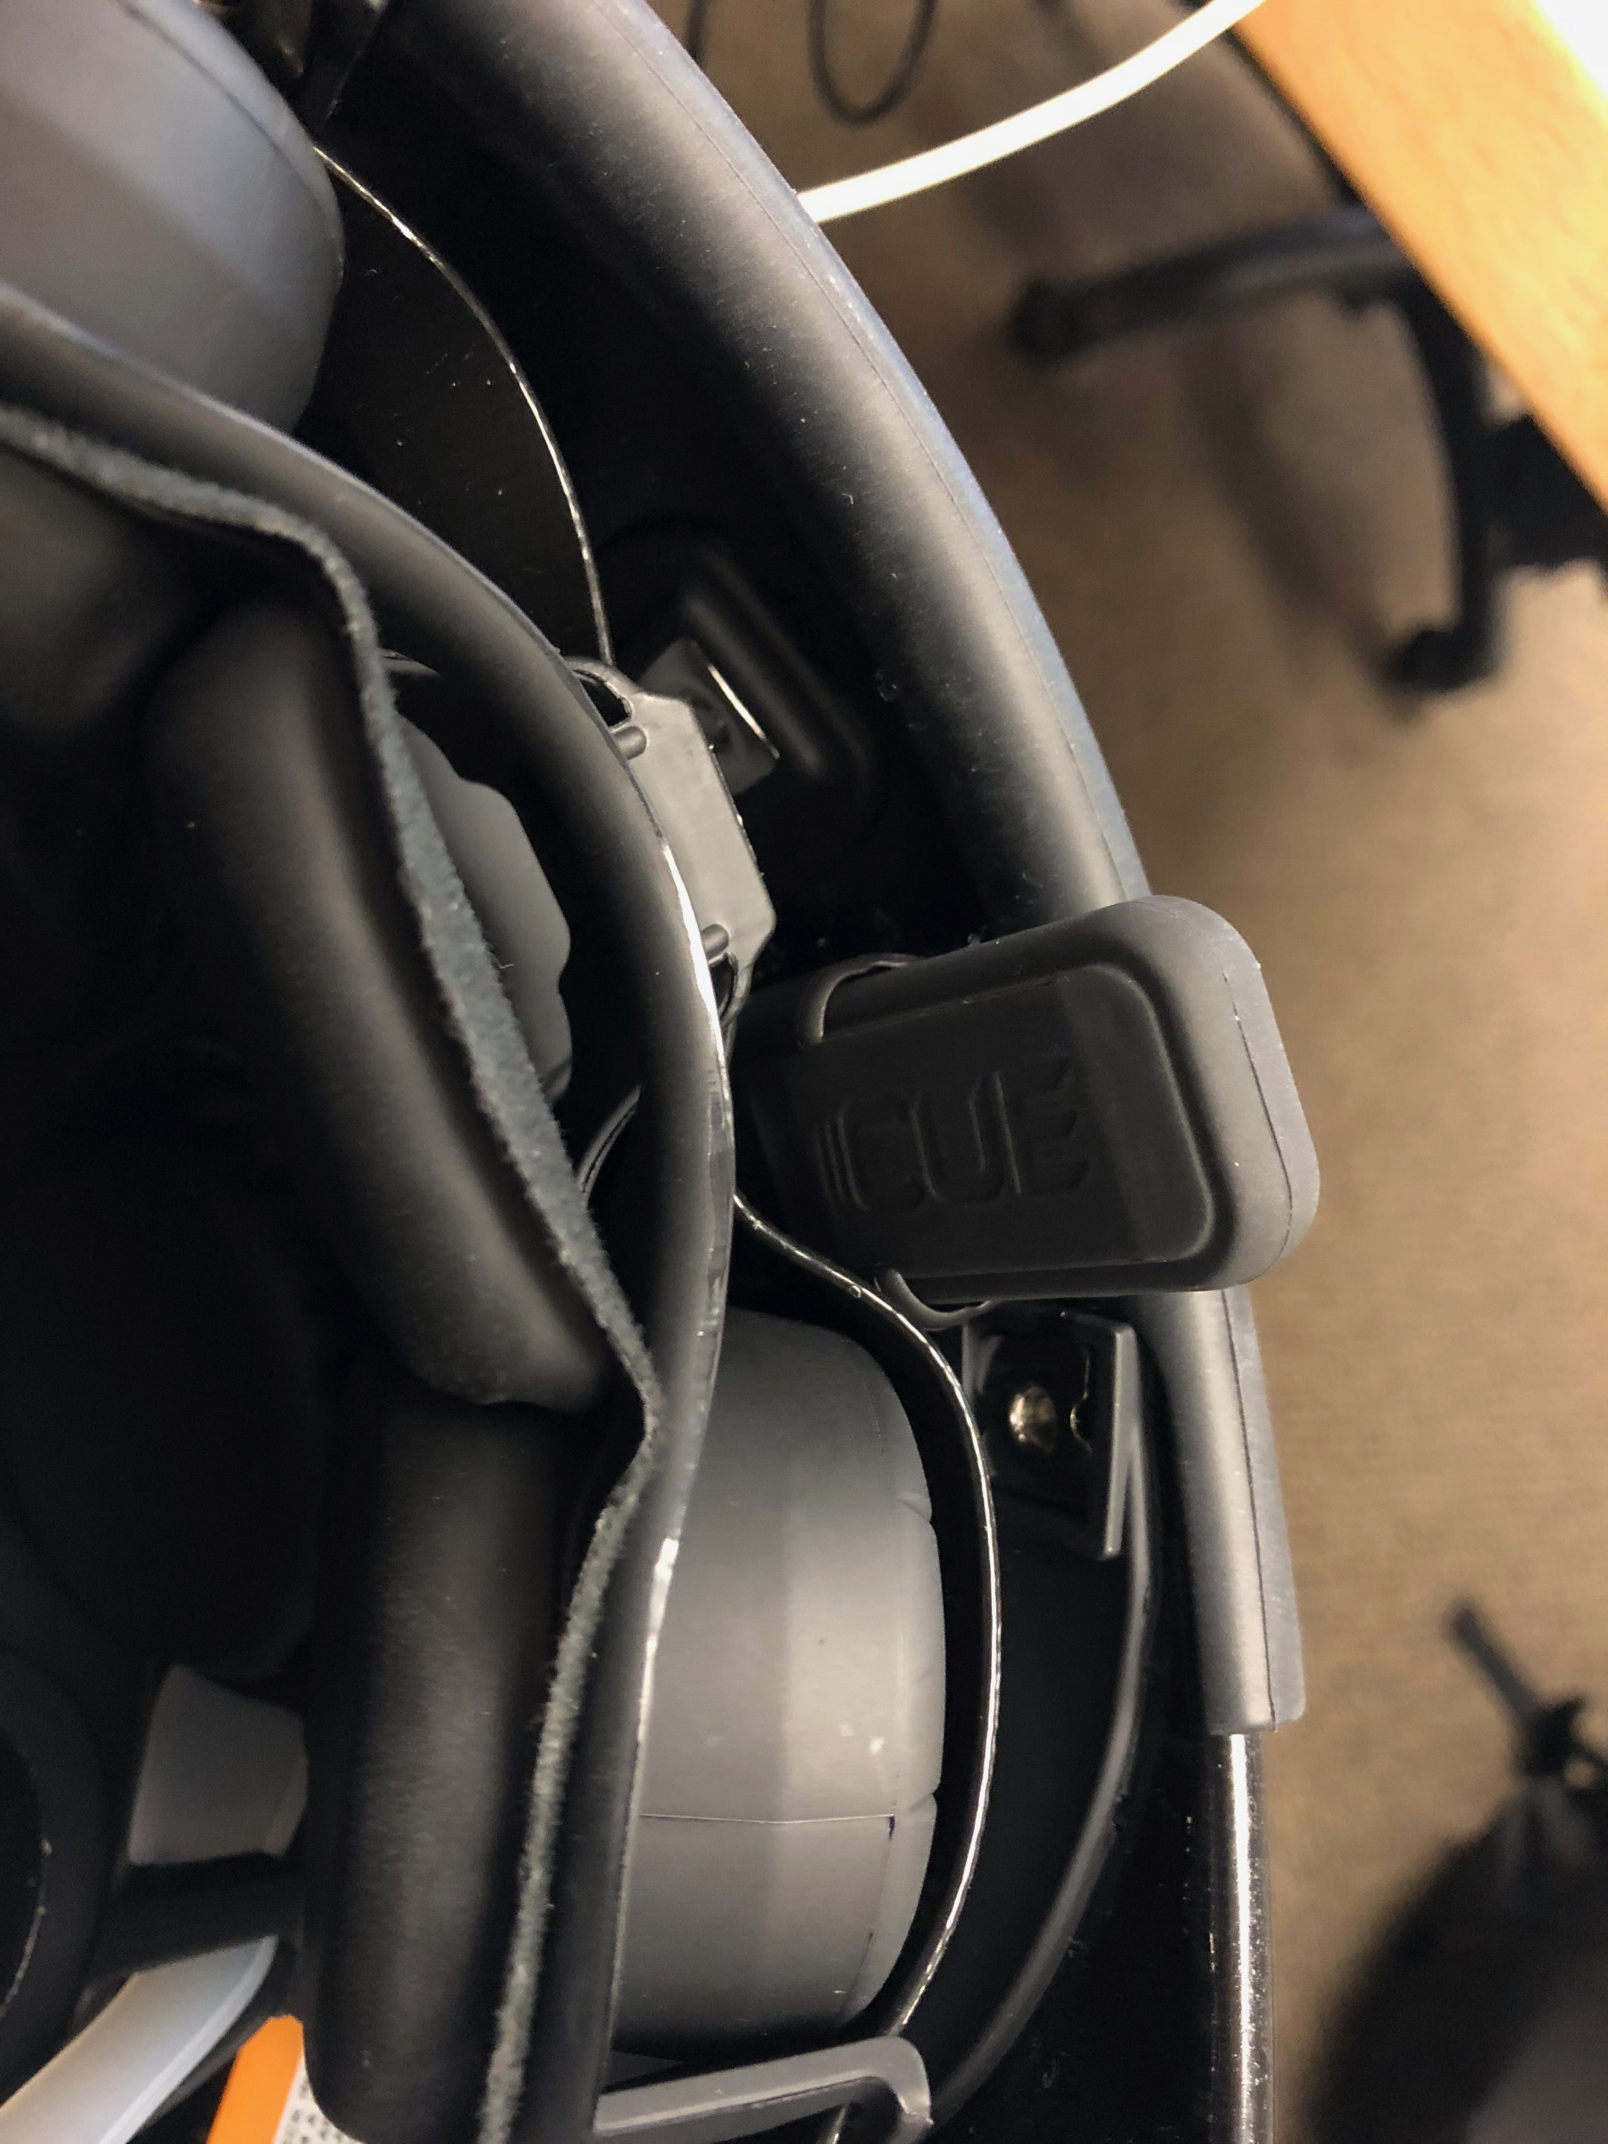

The second one, **6EPJ**, is located in the top right region of the front helmet. The device is horizontal with the lights facing the right ear when sliding into the clip.

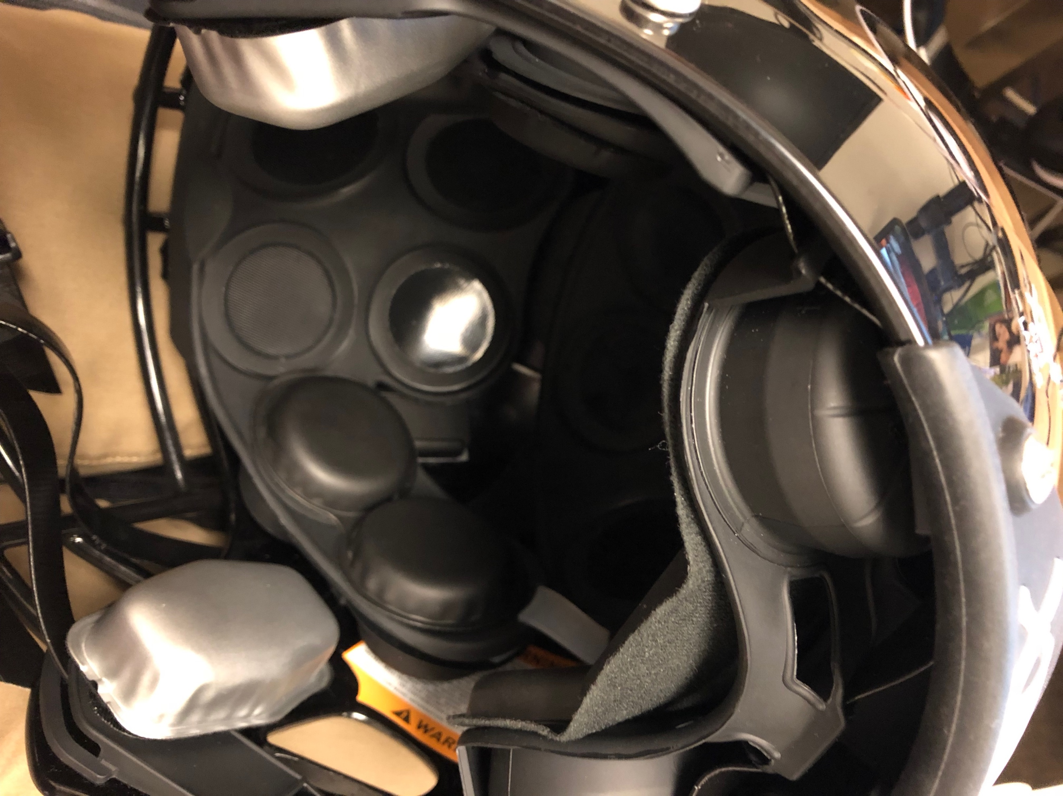

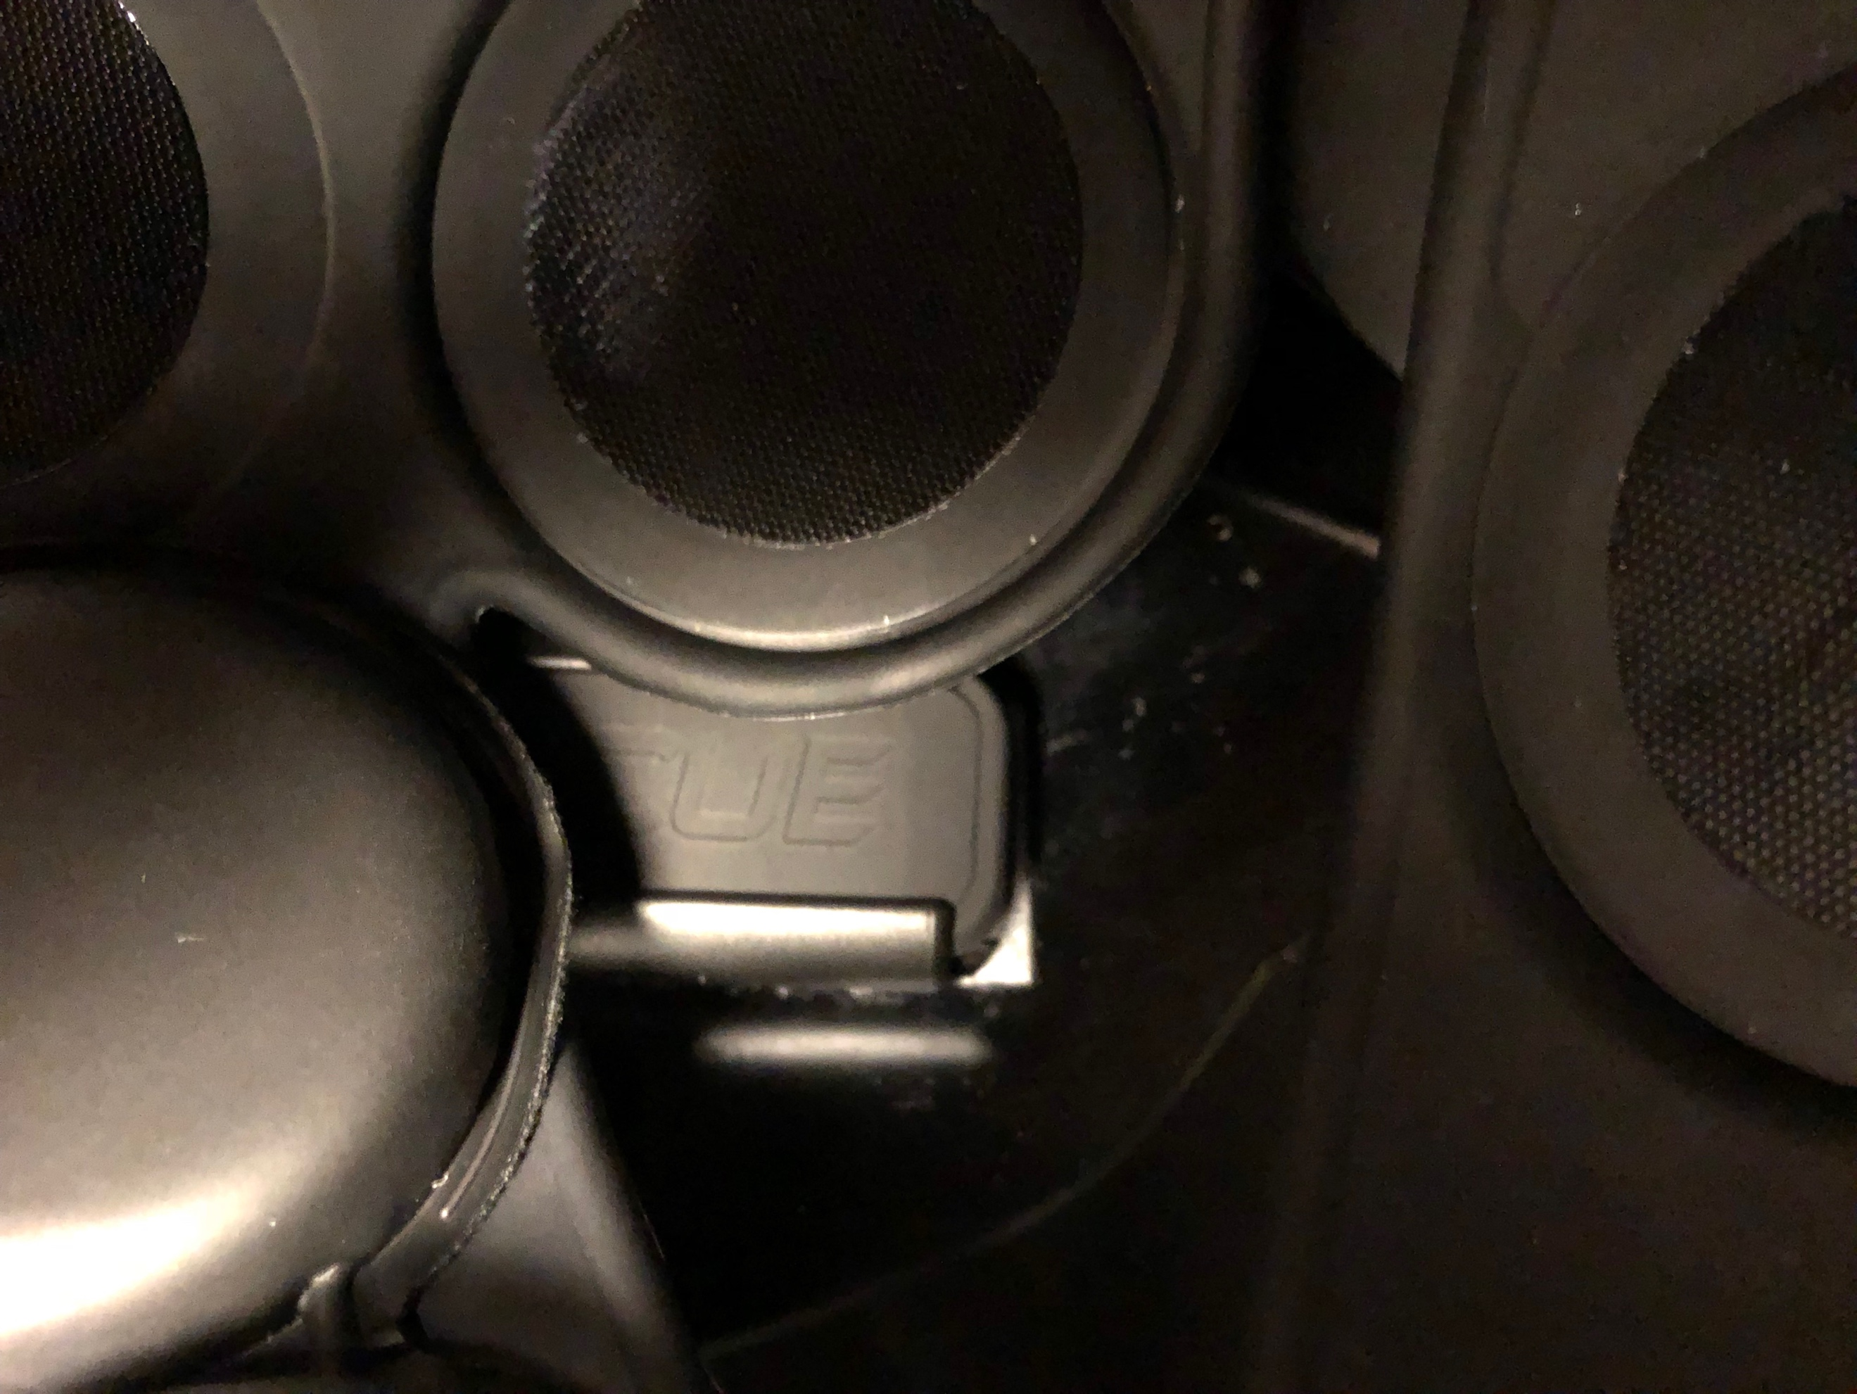

The third, **6EQ5**, is located in the top middle region of the helmet. This device has the lights facing down towards the back of the helmet and is oriented horizontally.

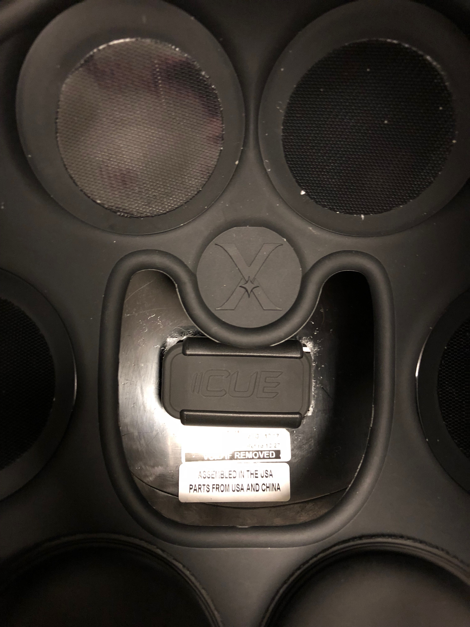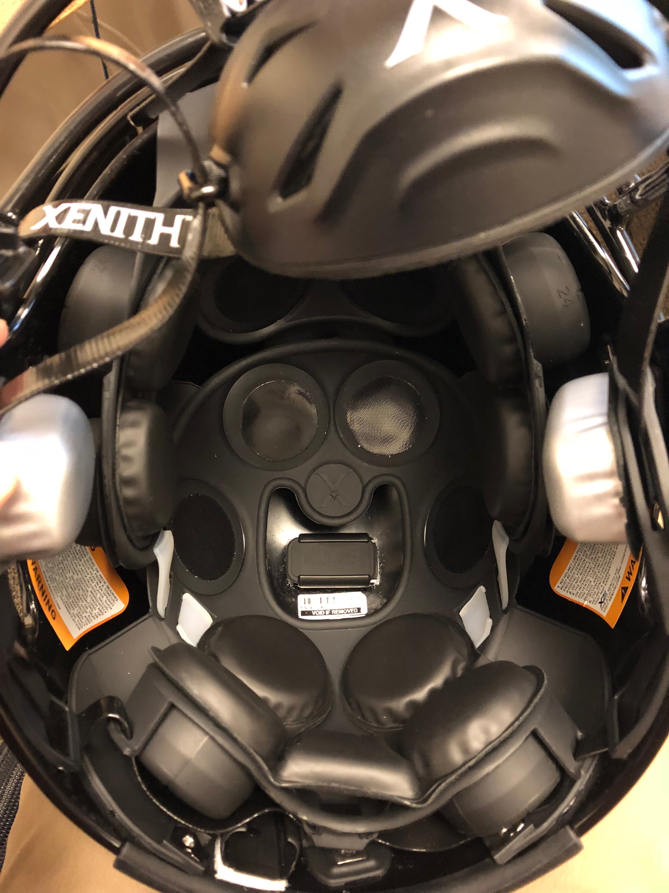

And the last one, **6EPW**, is the calibrated one attached to the top of the head of the test dummy just like Riddell and Lacrosse. This device is oriented vertically along the y-axis with the lights pointing to the right.

